**ECEN 610: MIXED SIGNAL INTERFACE HW.1**

Name: Yu-Hao Chen UIN: 435009528 Section: 601

Instructor: Sebastian Hoyos

TA: Haotian

一張含有 文字, 螢幕擷取畫面, 行, 繪圖 的圖片

AI 產生的內容可能不正確。

一張含有 文字, 字型 的圖片

AI 產生的內容可能不正確。

* **Decimation** is the process of **reducing the sampling rate Fs** of a digital signal.
* When a signal is downsampled (Decimation), its frequency components may exceed the new Nyquist frequency:

*F’nyquist= Fs/2M |M=decimate factor*

This causes high-frequency components to **fold back (alias) into the Nyquist range**, resulting in aliasing.

*FsD= Fs/M*

*Nyquist D= FsD/2*

Ex: Fs=10k Fin:3k and 6k Nyquist BW= 5k

3k no alias, but 6k alias back to 4k

After decimation M=2 FsD=5k Nyquist BW= 2.5k

Now 3k alias back to 2k, and (6k alias to 4k) and then back to 1k

Original:

一張含有 螢幕擷取畫面, 字型 的圖片

AI 產生的內容可能不正確。

Decimate:

一張含有 螢幕擷取畫面, 字型, 行, 設計 的圖片

AI 產生的內容可能不正確。

* Bin: When we perform Fast Fourier Transform (FFT) on the signal, the frequency axis will be divided into N bins, each bin represents a fixed frequency range.

Ex: Fs=10k Hz FFT N :1024

Bin: Δf= 10k/1024= 9.77Hz

Bin1: 0Hz Bin2: 9.77Hz Bin3: 19.54Hz …Bin1024

* FFT can only resolve discrete frequency points. These frequency points are determined by FFT bins(No matter before decimating or after). The bin intervals are:

*Bin size= Fs/N*

If alias frequency fa does not fall exactly on a certain bin, then it will have a frequency error in the FFT spectrum.

Therefore, we use:

*Fa= round(Fa/Bin size) * Bin size*

Align to the nearest FFT bin so that the FFT can parse it correctly.

Ex: Fs: 1000Hz, FFT N: 16, M=2 (FsD=500Hz ND=8), Fin:1200Hz

Original Fa: |1200- 1*1000|= 200Hz

FFT Bin: Fs/N= 62.5Hz

Normalized Fa: around(Fa/Bin size) *bin size= 187.5Hz (Bin3)

FaD= Fa mod FsD= 200 mod 500= 200Hz

Still need to normalized again.

* **Math for doing this**

1. Fa=|Fin-kfs|, k=round(fin/fs)
2. FaD= Fa mod FsD
3. Normalized Bin: Bin=round(Fa/Bin size) * Bin size (for both Fa FaD)

(Fa normalize and FaD normalized should be the same)

* After downclocking, the FFT Bin spacing (frequency resolution) remains unchanged.
* After downclocking, the number of FFT Bins is reduced, but the frequency point spacing remains the same.
* If alias frequency Fa corresponding bin remains unchanged, it will still fall into the same frequency bin after downscaling to ensure correct alignment.
* **Simulation**

Fs: 1000Hz, Fin: 1200Hz, FFT N:882, M=2

Estimation: fa=|fin-kfs|=200, k=round(fin/fs)=1

Bin size: Fs/N= 1000/822= 1.13379Hz

Normalized Fa= round(Fs/ Bin size) *Bin sized= 199.5468Hz

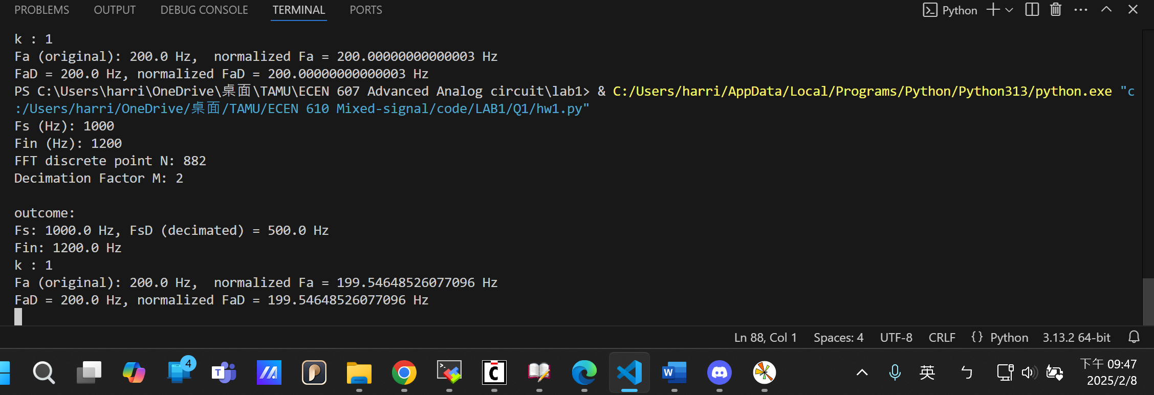一張含有 文字, 螢幕擷取畫面, 繪圖, 字型 的圖片

AI 產生的內容可能不正確。

Code for Fa and normalized

一張含有 文字, 螢幕擷取畫面 的圖片

AI 產生的內容可能不正確。

FFT and pre-plotting

一張含有 文字, 螢幕擷取畫面 的圖片

AI 產生的內容可能不正確。

Plotting

一張含有 文字, 電子產品, 螢幕擷取畫面, 陳列 的圖片

AI 產生的內容可能不正確。一張含有 文字, 螢幕擷取畫面, 軟體, 多媒體軟體 的圖片

AI 產生的內容可能不正確。